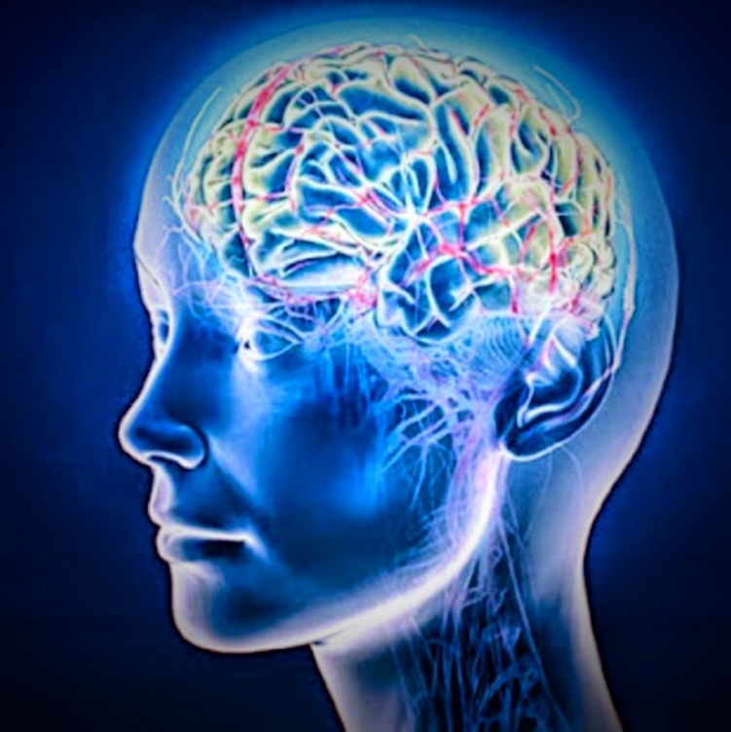

*4. Enjoy social activity*

1. ***Eat a healthy diet***
2. ***Challenge your brain***

Dementia is a word used to describe a group of symptoms that occur when some group of brain cells stop working properly. This happens inside specific areas of the brain that can affect how you think, remember and communicate.

Alzheimer’s disease is one of the most common forms of dementia.

The Alzheimer’s society (2015) reports that in the UK there are over 850,000 people living with dementia and this is set to rise to over one million by 2025.

YOU Are Not Alone

WHAT

## W

1. ***Be physically active***

Can we reduce the risk?

## Ws

Confusion

Behavioural changes

Misplacing objects

Social withdrawal

Symptoms

## Ws